**EXPERIMENT 2**

**BASIC LOGIC GATES (AND, OR & NOT)**

**Objective:**

To study the truth tables of various basic logic gates & to introduce the TTL integrated circuit AND, OR and NOT (inverter) gates.

**Required IC’s:**

1. 74LS04 hex-inverter (NOT) TTL IC
2. 74LS08 Quad-two input AND TTL IC
3. 74LS32 Quad-two input OR TTL IC

**Theory:**

**Part A: AND Gate Familiarization**

1. Insert a 7408 quad (4 in 1 package) two inputs AND gate IC into the logic Lab breadboard
2. Wire one of the AND gates as shown below. Refer to the datasheet for further IC information.
3. Experimentally verify that your AND gate is working properly by listing all input combination resulting outputs in truth table form.
4. LOW switch state = 0, HIGH switch state = 1

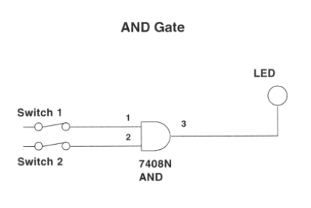

**Part B: OR Gate Familiarization**

1. Insert a quad 2-input Or gate into the breadboard.
2. Wire one of the OR gates such that its inputs can be entered from SW1 and SW2 and such that output state will be displayed on L1.
3. Experimentally verify that this OR gate is working properly as you have done previously by determining its truth table.

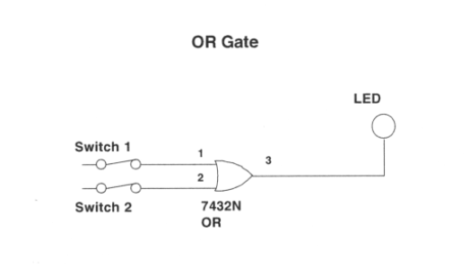

**Part C: NOT Gate Familiarization**

1. Insert a Hex inverter (6 in 1 package) into the breadboard.
2. Connect the input of one inverter to a switch and the output to a LED and verify the operation of the gate using a truth table.

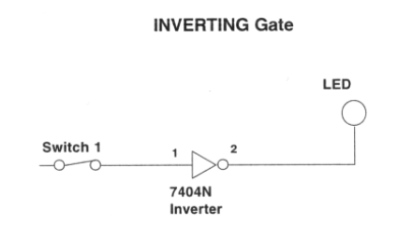

**SUMMARY OF INTERNAL ARCHITECTURE OF EACH IC**

7408 AND Gate



7432 OR Gate



7404 NOT Gate



**Analysis of Basic Logic Gates**

**7408 AND Gate Truth Table: 7432 OR Gate Truth Table:**

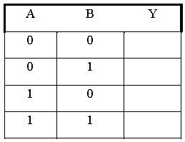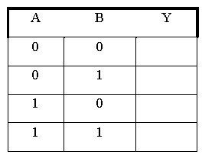

**7404 NOT Gate Truth Table:**

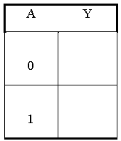

**CONCLUSION**